**LISTING**

**ALGORITMA DAN PEMROGRAMAN**

PERTEMUAN KE-8

1. PRACTICE 1
2. **CountDown**

public class CountDownWhile{

public static void main(String[]args){

int i= 10;

System.out.println("CountDown to Launch!");

while (i>=10){

System.out.println(i);

i--;

}

System.out.println("Blast off");

}

}

Output :

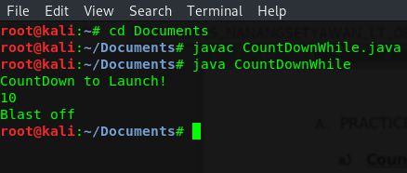

1. **Some while loops Never Run**

public class WhileLoopExample{

public static void main(String[]args){

int num= 0;

System.out.println("Let's count to 10!");

while (num<10){

num= num+1;

System.out.println("Number :"+num);

}

System.out.println("We have counted to 10! Hurrah!");

}

}

Output :

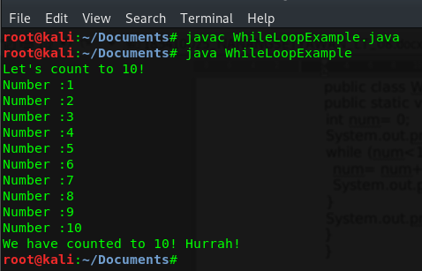

1. **Infinite Loop**

public class CountWhileInfinite{

public static void main(String[]args){

int i= 10;

System.out.println("CountDown to Launch!");

while (i>=10){

System.out.println(i);

i++;

}

System.out.println("Blast off");

}

}

Output :

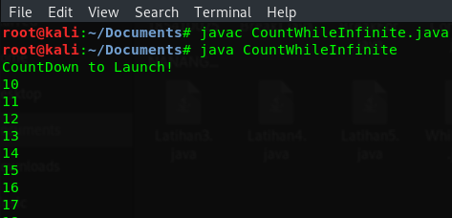

1. **While Loop and Scanner Class**

import java.util.Scanner;

public class WhileLoop1{

public static void main(String[]args){

Scanner sc= new Scanner(System.in);

int sum= 0;

System.out.println("Enter a number (-1 to quit):");

int num= sc.nextInt();

while (num!= -1){

sum= sum + num;

System.out.println("Enter a number (-1 to quit):");

num= sc.nextInt();

}

System.out.println("The sum is " + sum);

}

}

Output :

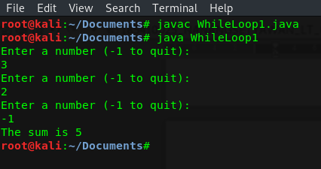

1. PRACTICE 2
2. **CountDown with do-while**

public class CountDownDoWhile{

public static void main(String[]args){

int i= 10;

System.out.println("CountDown to Launch");

do {

System.out.println(i);

i--;

}while (i>=0);

System.out.println("Blast off");

}

}

Output :

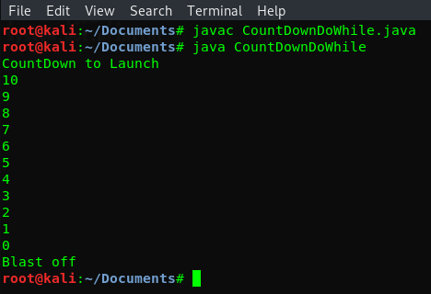

1. PRAKTICE 3
2. **Using break**

public class Break1{

public static void main(String[]args){

int i= 0;

while (i<10){

System.out.print(i+"\t");

i++;

if (i==4){

break;

}

}

}

}

Output :

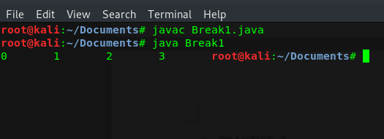

1. **Break in for Loop**

import java.util.Scanner;

public class BreakFor{

public static void main(String[]args){

Scanner in= new Scanner(System.in);

int numInputs= 10, input= 0, sum= 0, stopLoop= 999;

System.out.println("Enter 10 Numbers");

for (int i=0;i<numInputs;i++){

input= in.nextInt();

if (input==stopLoop){

break;

}

else{

sum += input;

}

}

System.out.println("The sum of numbers : "+sum);

}

}

Output :

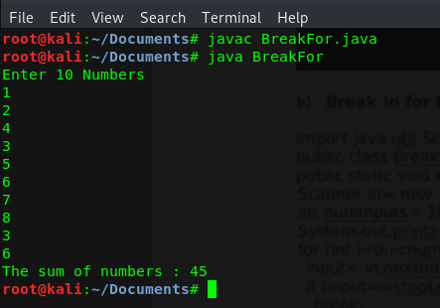

1. **Using Continue**

public class Continue1{

public static void main(String[]args){

for(int i=0;i<10;i++){

if(i==4){

continue;

}

System.out.print(i+"\t");

}

}

}

Output :

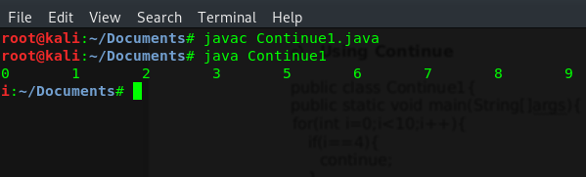

1. **Computing the sum of number**

public class Continue2{

public static void main(String[]args){

int counter= 0;

int sum= 0;

while (counter<100){

counter++;

if(counter%10==0){

continue;

}

else{

sum+= counter;

}

}

System.out.println("Sum of 1-99 :"+sum);

}

}

Output :

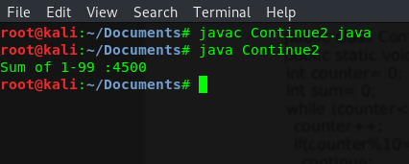

1. EXERCISE
2. **Make a programs using while loop**

import java.util.Scanner;

public class Latihan1{

public static void main(String[]args){

int integer;

Scanner sc= new Scanner(System.in);

System.out.print("Type a non-negatif integer: ");

integer= sc.nextInt();

while (integer<0){

System.out.print("Invalid number, try again: ");

integer= sc.nextInt();

}

System.out.println("The square of "+ integer +" is "+integer*integer);

}

}

Output :

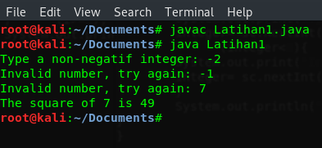

1. **Make a programs to sum 10 first number with while loop**

import java.util.Scanner;

public class Latihan2{

public static void main(String[]args){

Scanner in= new Scanner(System.in);

int i= 0, numInputs= 10, input= 0, sum= 0;

System.out.println("Enter 10 Numbers");

while(i<numInputs){

input= in.nextInt();

i++;

sum += input;

}

System.out.println("The sum of numbers : "+sum);

}

}

Output :

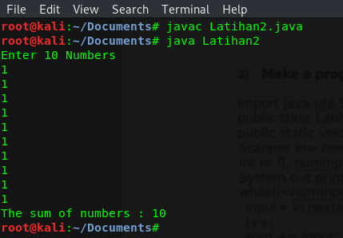

1. **Make a programs to sum 10 first number with do-while loop**

import java.util.Scanner;

public class Latihan3{

public static void main(String[]args){

Scanner in= new Scanner(System.in);

int i= 0, numInputs= 10, input= 0, sum= 0;

System.out.println("Enter 10 Numbers");

input= in.nextInt();

do{

input= in.nextInt();

i++;

sum += input;

}while(i<numInputs);

System.out.println("The sum of numbers : "+sum);

}

}

Output :

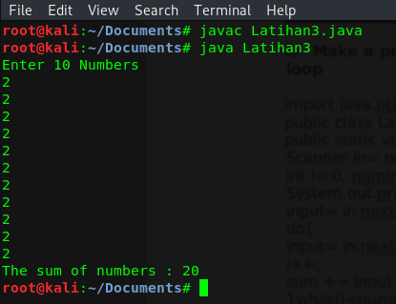

1. **Modification WhileLoop1 in practice 1.d using do-while loop**

import java.util.Scanner;

public class Latihan4{

public static void main(String[]args){

Scanner sc= new Scanner(System.in);

int sum= 0;

System.out.println("Enter a number (-1 to quit):");

int num= sc.nextInt();

do{

sum= sum + num;

System.out.println("Enter a number (-1 to quit):");

num= sc.nextInt();

}while (num!= -1);

System.out.println("The sum is " + sum);

}

}

Output :

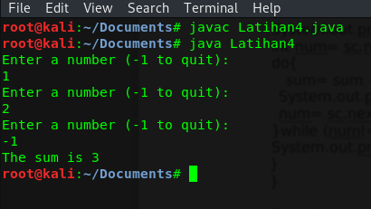

1. **Make program with break and continue with determinate**
2. if the number is even, the number not show
3. Execution from loop stopped if counter loop reach 7

public class Latihan5{

public static void main(String[]args){

int counter= 0;

while (counter<10){

counter++;

if(counter%2==0){

continue;

}

if(counter>7){

break;

}

System.out.print(counter+"\t");

}

}

}

Output :

